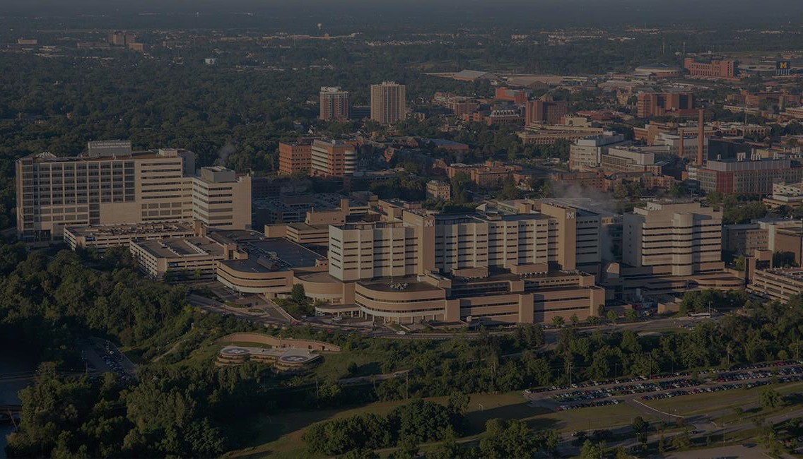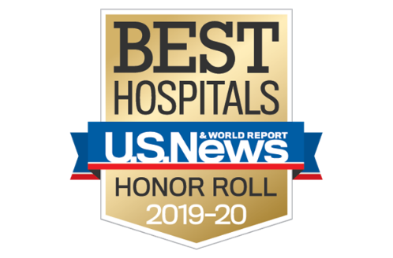

**MICHIGAN MEDICINE AND VA ANN ARBOR HEALTHCARE SYSTEM POSTDOCTORAL CONSORTIUM IN ADULT CLINICAL PSYCHOLOGY**

**POSTDOCTORAL FELLOWSHIP BROCHURE**

**Application Deadline: December 1, 2023**

**Four positions anticipated beginning in September 2023**

* **1 Adult Positions (Michigan Medicine)**
* **2 Adult Positions (VA Ann Arbor Healthcare System)**
* **1 Adult Women’s Position (VA Ann Arbor Healthcare System)**

**ACCREDITED BY THE COMMISSION ON ACCREDIDATION AMERICAN PSYCHOLOGICAL ASSOCIATION**

Table of Contents

Michigan Medicine/VA Ann Arbor Healthcare System Training Network Overview……......3

Education 5

Clinical Psychology: Clinical Experiences 5

Michigan Medicine 7

VA Ann Arbor Healthcare System 8

Clinical Adult Psychology: Research Experiences 10

Current Fellows 13

Training Staff Biographis 14

Ann Arbor Life and Community 24

Application Process 25

# 

# Michigan Medicine/VA Ann Arbor Healthcare System Training Network Overview

Michigan Medicine (MICHMED) and the VA Ann Arbor Healthcare System (VAAAHS) have collaborated to create a Network of training programs, consisting of two dual-site (consortium) programs and two single-site programs. The two consortium programs are in [Clinical Neuropsychology](https://medicine.umich.edu/dept/psychiatry/education/psychology-postdoctoral-training/specialty-areas/clinical-neuropsychology-consortium) and [Clinical Psychology](https://medicine.umich.edu/dept/psychiatry/education/psychology-postdoctoral-training/specialty-areas/clinical-psychology-consortium), and the single-site programs are in [Clinical Child Psychology](https://medicine.umich.edu/dept/psychiatry/education/psychology-postdoctoral-training/specialty-areas/clinical-child-psychology) and [Mental Health Treatment and Research (at SMITREC)](https://medicine.umich.edu/dept/psychiatry/education/psychology-postdoctoral-training/specialty-areas/smitrec-va-fellowship-program-mental-illness-treatment-research). All four programs are accredited by the American Psychological Association (next site visit 2022). The overall training network is led by the Network Training Director, J. Todd Arnedt, Ph.D.

MICHMED and VAAAHS provide a rich interdisciplinary training environment with seminars, invited lectures, and opportunities for collaboration with faculty across disciplines and departments. Postdoctoral fellows are offered a diverse set of clinical experiences in assessment, treatment, and consultation with a focus on empirically-supported treatments; mentorship in conducting independent clinical research; and didactics focused on professional development, the integration of science and practice, cultural and individual diversity, and ethics and the law.

The training philosophy of the programs within the Network is rooted in the scientist-practitioner model. The institutional philosophy and values of all the Network programs are focused on normative healthcare ethical values of beneficence, non-malfeasance, and social contract in a context of public service. The overarching aim of the network programs is to develop practitioner-scientists to an advanced level so that they are capable of functioning successfully in a range of occupational settings for psychologists.

To serve this overall goal, the training network welcomes applications from individuals attending accredited clinical/counseling psychology programs. The program selects candidates whose academic and clinical preparation, supervisor recommendations, and perceived synergy with our programs are ideally suited. Thus, we hope to identify postdoctoral fellows who demonstrate a readiness and desire to learn and develop professionally. To that end, the training network provides the breadth and depth of experiences in assessment, treatment, consultation, and scholarly support of practice and research.

Fellows in the Clinical Psychology Consortium complete training after one year; fellows at the MICHMED site of the Consortium have the option to extend their training for a second year to enhance their research and clinical training competencies. Questions about the accreditation and the accreditation process can be addressed to:

Office of Program Consultation and Accreditation American Psychological Association  
750 First Street N.E., Washington DC, 20002  
Phone: 202-336-5979

**Clinical Psychology (Adult) Consortium**

The Clinical Psychology Consortium provides specialty training in the acquisition and application of evidence-based practice in clinical adult psychology. Clinical training occurs in inter-professional settings with a specialized research emphasis for each fellow. In keeping with the goals of the broader network of training programs, the Clinical Psychology Consortium develops professionals to an advanced level in the assessment, diagnosis, and treatment of individuals with a variety of psychiatric disorders across the adult lifespan. Fellows select a preferred primary site (MICHMED or VAAAHS) when applying to the program, although clinical and research experiences are encouraged at both sites. Our Consortium prepares fellows to direct clinical programs, educate professional psychologists, and perform programmatic research. Clinical research opportunities are available in a range of areas, including mood disorders; women’s mental health; sleep and circadian disorders; health psychology; anxiety and related disorders (e.g., posttraumatic stress disorder); substance use disorders; psychotic disorders; primary care mental health integrations; and mental health recovery.

**Clinical Psychology Sections**

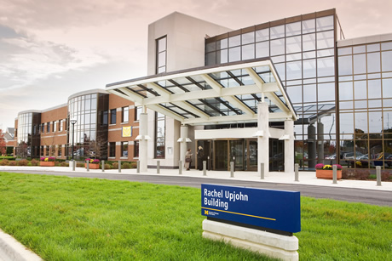

**Michigan Medicine (MICHMED) Clinical Adult Section**

The MICHMED Clinical Adult Section provides outpatient assessment, consultation, and treatment services across the range of adult psychiatric disorders.

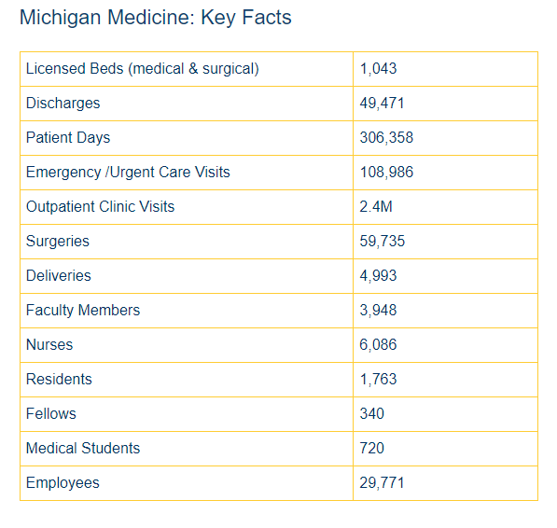***MICHMED Facilities***  
Michigan Medicine is one of the largest hospitals in Michigan and a premier academic medical center made up of the University of Michigan Health and University of Michigan Medical School. Michigan Medicine is known for conducting cutting-edge biomedical research and delivering premier patient care. According to the US News and World Report, the institution ranks among the best in the nation in a range of both pediatric and adult specialties. Michigan Medicine consists of 9 Basic Science Departments, 20 Clinical Departments, and 50 Interdisciplinary Departments, Programs, Centers and Institutes. Major clinical care facilities of Michigan Medicine include the University Hospital; the Rogel Cancer Center; C.S. Mott Children's Hospital; Von Voigtlander Women's Hospital; and the A. Alfred Taubman Health Care Center on the main medical campus, and at outpatient health centers in close proximity, including the East Ann Arbor Health and Geriatrics Center, Commonwealth Neuropsychology Outpatient Facilities, Kellogg Eye Center, Turner Geriatric Center, and the VA Ann Arbor Healthcare System (VAAAHS, with its psychology and psychiatry training programs). Adding to the University’s research capabilities in 2009, UM acquired the North Campus Research Complex—formerly the Pfizer property—which is close to the East Ann Arbor Medical Campus and encompasses four parcels of land and 30 buildings. The acquisition added nearly two million square feet of sophisticated laboratory facilities and administrative space, along with furnishings.

Postdoctoral activities for Clinical Psychology Consortium fellows take place primarily in the Department of Psychiatry’s Rachel Upjohn Building, a state-of-the-art facility located on the East Ann Arbor Medical Campus that is home to the University of Michigan Depression Center and nearly all Michigan Medicine outpatient psychiatry services for children and adults, as well as the University of Michigan Addiction Treatment Services' outpatient programs for teens and adults. The building includes over 39,000 net square feet (over 54,000 BGSF) and additionally houses research laboratories for NIH-funded investigators, clinical investigation facilities and offices, educational facilities, and treatment clinics.

**VAAAHS Clinical Adult Section**

The VAAAHS Clinical Adult Section has a long history of evaluating and treating Veterans in integrated care and outpatient settings.

***VAAAHS Facilities***  
The VA Ann Arbor Medical Center is located adjacent to the University of Michigan campus and medical center. Our medical center is a 105-bed general medical-surgical hospital, which includes an inpatient psychiatric unit, outpatient mental health clinics, substance use treatment and community-based psychiatric and recovery services. Community Based Outpatient Clinics (CBOCs) provide outpatient mental health services to Veterans in the VAAAHS catchment area but residing nearer to Adrian, Canton, Flint, Howell and Jackson, Michigan, and to Toledo, Ohio. Mental Health facilities have been fully updated in the past few years. Offices for fellows have modern support facilities, with full computer access to the University of Michigan information systems and library, as well as VAAAHS information systems.

# 

# EDUCATION EXPERIENCES

In addition to a core curriculum, fellows in the MICHMED/VAAAHS Clinical Psychology Consortium have several unique learning opportunities, ranging from targeted coursework to visiting lectures. Educational opportunities include both mandatory training requirements designed to ensure smooth and consistent progress throughout the training program, and optional training opportunities that can be pursued to further enrich the training experience.

***Didactic Offerings:***

* Weekly Postdoctoral Forum
* Weekly Grand Rounds (MICHMED and VAAAHS)
* Monthly International Case Conference
* Monthly Bioethics Conference (Minimum two per year)
* Additional Formal Didactics (e.g., Rackham Professional Development Diversity, Equity, and

Inclusion Certificate)

* Invited Lecturers throughout MICHMED and VAAAHS

**Teaching/Supervision Experiences**

Fellows are provided with the opportunity to perform clinical supervision of predoctoral practicum students and interns. Additional supervision of undergraduate students who work with faculty and fellows on a wide variety of research projects is also available. Fellows may also assist faculty with teaching seminars and take part in an annual half-day supervision skills workshop.

# Clinical Experiences

Adult fellows develop individualized training plans comprised of experiences selected by the fellows in conjunction with their faculty mentor. Clinical experiences typically account for 50% or more of fellow activities and may occur exclusively at one site or across both the MICHMED and VAAAHS sites. The figure below provides an overview of the clinical opportunities at the two sites followed by descriptions of the specific clinical rotations.



## Michigan Medicine Clinical Rotations

**Anxiety Disorders Clinic**

The Adult Anxiety Clinic conducts initial consultations and follow-up visits (individual and group therapy) for adults with anxiety, stress, obsessive-compulsive, and related disorders. We have been treating anxiety disorders since the mid-1970s using evidence-based approaches. We are one of the oldest such clinics in the country and are committed to the integrated utilization of both psychological and pharmacological approaches to the treatment of anxiety. We are a large multidisciplinary team consisting of clinicians and researchers including psychiatrists, psychologists, social workers, and nurse practitioners. We work with adults experiencing a wide range of anxiety disorder presentations. Fellows will attend integrated team meetings and will learn to provide specialized assessments and individual cognitive behavioral therapy for a variety of anxiety disorders, including Exposure and Response Prevention (ERP) for OCD, cognitive processing and prolonged exposure therapy for PTSD, habit reversal therapy for body focused repetitive behaviors, and other related approaches. There are also opportunities for fellows to participate in our group therapy programs.

**Depression Clinic**

The Depression Clinic focuses on assessing and treating patients with depressive disorders, although cases commonly have psychiatric and medical comorbidities. The team is multidisciplinary and includes psychiatrists, psychiatric residents, social work fellows, psychologists, and at times postdoctoral psychology fellows. Participants gain skills in differential diagnosis, treatment planning, and providing evidence base treatments for mood and related disorders. Cognitive Behavioral Therapy (CBT), Interpersonal psychotherapy (IPT), Dialectical Behavior Therapy (DBT), and pharmacotherapy are the mainstay of evidence-based treatments provided, while acceptance and commitment therapy (ACT) may be included when deemed appropriate. In addition to assessment, diagnosis, and treatment planning, the depression clinic also contains a didactic component on specific topics of interest.

**Behavioral Sleep Medicine (BSM) Clinic**

The BSM Clinic conducts initial consultations and follow-up visits (individual and group therapy modalities) for adults 18 years of age and older with sleep disorders amenable to evidence-based sleep treatments (e.g., CBT for insomnia). The primary referrals to the BSM clinic are for insomnia, hypnotic discontinuation, circadian rhythm sleep-wake disorders, and adherence to medical regimens (e.g., Continuous Positive Airway Pressure, CPAP). Many initial consultations are conducted in a multidisciplinary context, where clinical psychologists work side-by-side with sleep medicine physicians. Fellows are additionally encouraged to rotate through other Michigan Medicine sleep-related clinics, including the General Sleep Disorders Clinic, Pediatric Sleep Clinic, and Alternatives to CPAP Clinic, where they gain exposure to various medical specialties involved in the care of patients with sleep disorders. (e.g., Neurology, Pulmonology, Pediatrics, Otolaryngology, Oral and Maxillofacial Surgery).

**Early Psychosis (PREP) Clinic**

The PREP Clinic conducts initial consultations and early interventions for adolescents and young adults 14-30 years old presenting with early psychosis or symptoms suggestive of increased risk for developing a psychotic disorder (attenuated psychosis syndrome or “prodromal” psychosis). We are a Coordinated Specialty Care (CSC) clinic providing a range of services to facilitate recovery, including individual and group CBT for psychosis (CBTp), family psychoeducation, multifamily groups, social skills training, medication management, and care coordination. We are a multidisciplinary team consisting of clinicians and researchers from multiple disciplines, including clinical psychologists, neuropsychologists, psychiatrists, social workers, and nurse practitioners. We are part of the learning health system within an [Early Psychosis Intervention Network (EPINET)](https://nationalepinet.org/) funded by the NIMH. Fellows have the opportunities to learn and provide specialized assessments and individual, family, and group interventions for this young population.  Fellows are also encouraged to participate in local educational outreach activities to help promote early detection and intervention on campus and in the community.

**University of Michigan Addiction Treatment Service (UMATS)**

The University of Michigan Addiction Treatment Service is an outpatient substance use disorder treatment center located in the Department of Psychiatry, Rachel Upjohn Building. In addition to psychiatric services (medication management, outpatient detoxification, and opioid substitution treatment), psychotherapy services include intensive outpatient programming, aftercare groups, dual diagnosis groups, family/couple’s therapy, individual therapy, and treatment for healthcare professionals. Fellows will work collaboratively in our interdisciplinary team of psychiatrists, social workers, psychologists, and nurses to treat patients with substance use or dual diagnoses. Fellows will have the opportunity to conduct individual and group therapies using evidence-based practices. Additional experiences in our multi-disciplinary collaborative care clinic focused on Alcoholic Liver Disease in the main hospital may also be available.

**Women and Infants Mental Health Clinic (WIMHC)**

The WIMHC is an outpatient clinic in the Department of Psychiatry in the University of Michigan Health System. Our clinic is staffed by a multidisciplinary team of psychiatrists, nurse-practitioners, psychologists, and social workers. Trainees on the team include psychology practicum students, psychiatry fellows, and social work interns and fellows. As a tertiary care clinic, we specialize in assessment and treatment of mental health conditions in women, primarily during pregnancy, postpartum, and other times of hormonal change (e.g., perimenopause). We also offer dyadic-based psychotherapy services for mothers and their infants and young children. As one of very few clinics in Michigan that specialize in perinatal mental health, we serve a diverse population, often with medical and psychiatric comorbidities. As part of this rotation, postdoctoral fellows complete a mentorship in Interpersonal Psychotherapy.

## VA Ann Arbor Healthcare System Clinical Opportunities

**Health Psychology (Integrated Care)**

Integrated, health psychology offerings emphasize brief functional assessments and interventions for Veterans presenting in a wide range of ambulatory care settings. Exposure to interprofessional practice and the “medical home” primary care as well as Whole Health models are important elements in learning. The fellow can gain experience with primary care mental health integration, chronic pain management, MOVE! weight management and other patient education programs, as well as tobacco cessation services.  Working with the Pain Clinic and Primary Care, the fellow learns comprehensive, bio-psychosocial assessments and provides integrated CBT-based chronic pain management services. Fellows can be integral components of the weight management, accredited diabetes education, or cardiac and pulmonary rehabilitation programs, facilitating behavior change enhancement and stress management classes.  Using Motivational Interviewing (MI) and Acceptance and Commitment Therapy (ACT) principles, fellows may collaborate with Pharmacy and Nursing to offer tobacco cessation services as well.  Integrated care opportunities are also available with Oncology, Sleep and Women’s Health Clinics. The fellows may also conduct organ transplant and/or bariatric surgery mental health evaluations.  Therefore, assessment and consultation skills, and both individual and group intervention modalities are available experiences.  We aim to provide the fellow with experience in working as part of medical teams across the ambulatory care settings and in-patient integrated care opportunities can also be pursued. Fellows can enhance consultation and health coaching skills with other healthcare clinicians, and practice serving as a representative of the field of psychology in the broader healthcare setting.

**Mental Health Clinic (MHC)**

Training opportunities in the Mental Health Clinic include thorough diagnostic assessment and psychotherapy training with a wide variety of outpatient clients. Fellows may learn risk assessment and crisis intervention strategies, interviewing and assessment skills, and other screening techniques. Individual therapy cases and group therapy experiences (e.g., depression and anxiety) are available. The clinic offers opportunities to work closely with a variety of mental health professionals. Treatment approaches include empirically supported strategies, such as CBT, Dialectical Behavior Therapy (DBT), Motivational Interviewing, and Solution-Focused/Strategic Therapies. There are opportunities for fellows to work with individuals from diverse backgrounds who present with a wide range of psychopathology. There is flexibility to accommodate individual fellow interests in terms of caseload, development and implementation of treatment groups, and program assessment and evaluation activities. Fellows will also have the opportunity to conduct some of these services using telehealth technology. The Ann Arbor VA offers video on demand visits to veterans located in the community-based outpatient clinics (CBOCs) or in their homes.

**Posttraumatic Stress Disorder Clinical Team (PCT)**

The PCT functions as an outpatient specialty clinic within the medical center. This multi-disciplinary team provides comprehensive assessment, treatment, and research-based protocols to patients with PTSD. The fellow may attend teaching rounds, perform assessments, and follow cases within this specialty clinic.Fellows will have opportunities for training and practice in specialized PTSD evaluation and empirically supported treatments, including Prolonged Exposure (PE) and Cognitive Processing Therapy (CPT). In addition to weekly individual supervision, fellows participate in weekly PCT staff meetings. This includes clinical case presentations, evaluation presentations, and didactic presentations on topics related to PTSD.

**Psychosocial Rehabilitation & Recovery (PSR&R)**

Psychosocial Rehabilitation and Recovery (PSR&R) offers training opportunities across multiple specialty clinics (e.g., Psychosocial Rehabilitation & Recovery Center; Mental Health Intensive Case Management, Acute Inpatient Mental Health, Compensated Work Therapy, etc.) spanning the full continuum of care. The focus of PSR&R is weighted towards improving Veterans’ functioning, and role functioning. This means we work to help individuals develop and pursue their personal living, learning, and socialization goals to help them move forward in their mental health recovery. PSR&R offers multiple opportunities in initial and diagnostic assessments; recovery action planning; group-based EBPs (e.g., Cognitive Behavioral Social Skills Training, Illness Management & Recovery, Dual Diagnosis, etc.); individual therapy (e.g., CBT for Psychosis and Solution-Focused approaches); community-based work helping Veterans apply the skills they’ve learned or developed; program development and evaluation; and working with peer-based services. Additional PSR&R opportunities are also available in the areas of home visits (MHICM), outreach, and working with community partners.

**Substance Use Disorders Section (SUDC & SUD IOP)**

The SUD experiences include opportunities for training in assessment and diagnosis, treatment planning, participating in multidisciplinary treatment, and training in empirically supported intervention approaches for individuals with substance use disorders with and without comorbidities. Psychological treatment approaches across levels of care include Cognitive Behavioral Therapy (CBT), Motivational Interviewing/Enhancement Therapy, Behavioral Couples Therapy, Harm Reduction, Mindfulness Based Relapse Prevention, and Contingency Management. The clinic provides core therapy groups using CBT, as well as a number of specialty interventions, (e.g., emotion regulation, behavioral pain management, insomnia treatment). There are opportunities for fellows to work with individuals presenting with a wide range of psychopathology from diverse backgrounds in both inpatient, intensive outpatient,and outpatient settings. There is also flexibility to accommodate individual fellow interests in terms of caseload, program assessment/evaluation, and research activities.

**Women Veterans’ Mental Health**

This experience involves evidence-based care in the outpatient mental health clinics (MHC, SUDC, and PCT) and/or health clinics. The Women’s VAAAHS Fellow may elect to focus in a single clinic or can collaborate with supervisors to incorporate clinical care opportunities from multiple clinics and sites. The focus on women’s mental or behavioral health training may involve participation in both individual and group therapy offerings specifically for women Veterans and training in common intersections between military culture, gender issues, and other aspects of diversity. Options include trauma-focused treatments for PTSD (CPT, PE), DBT, Interpersonal Violence, Wellness Group for Women, Military Sexual Trauma evaluation and interventions for women. Fellows with interest in providing trauma-focused therapy with Women Veterans diagnosed with PTSD are required to attend the PE and CPT trainings at the beginning of the fellow year. Fellows may be integrated into the Women’s Health Clinic (4 hours per week) to provide consultation/liaison and/or brief interventions to women presenting for specialty medical assessments or care. There are several current research options available throughout the service. Fellows are afforded many opportunities to be integrally involved in administrative activities (i.e., membership in the Women Veterans’ Mental Health Working Group, projects associated with mental health service aspects of the VA Ann Arbor Healthcare System’s Women Veterans’ Programming Committee).

**Couples & Family Intervention**

Fellows have the opportunity to see couples utilizing the Behavioral Couples Therapy Model (BCT), Behavioral Family Therapy for SMI, and the Integrative Behavioral Couples Therapy model (IBCT). Cases may be referred for numerous presenting problems (marital distress, substance use, SPMI, etc.). Fellows may also provide evidence-based CBT for partner abuse (Strength at Home). Opportunities for providing parenting skills training for Veterans and family education are also available. Opportunities for administrative activities are available as well. As there are interns on the couples/family rotation, this experience also offers the opportunity to supervise an intern in this area of focus. Research projects in this area utilize data sets from an RCT and from the clinical data.

# Research Experiences

We believe that progress in understanding human behavior can come from testing hypotheses generated from clinical observations. Research involvement is a necessary component of the modern clinical psychologist and therefore is a significant emphasis of the Clinical Psychology Consortium training program. Fellows at the VAAAHS typically include a research component in their individualized development plan ranging from 10-40% of their training time. Here, fellows are encouraged to work with a faculty member’s current research or produce a small original study that complements the interest of a faculty psychologist who could serve as a mentor for the project. MICHMED fellows are matched with an academic/research mentor and spend up to 40% of their time in research activities, with an emphasis on development and execution of original scientific work as well as manuscript/grant writing.

Consortium training faculty are involved in many kinds of clinical research efforts, including VAAAHS- and NIH-funded projects (often in conjunction with other University of Michigan faculty). These activities provide students with knowledge of psychology's interface with related health disciplines. Faculty is involved with research projects in a variety of clinical departments, including Surgery, Neurology, Internal Medicine, and Family Medicine, and research programs, such as the [VAAAHS Serious Mental Illness Treatment Research and Evaluation Center (SMITREC)](https://medicine.umich.edu/dept/psychiatry/education/psychology-postdoctoral-training/specialty-areas/smitrec-va-fellowship-program-mental-illness-treatment-research), the [University of Michigan Addiction Center](https://medicine.umich.edu/dept/psychiatry/programs/addiction-center), the [Molecular and Behavioral Neuroscience Institute](https://medicine.umich.edu/dept/psychiatry/programs/mbni), and the [Institute for Healthcare Policy and Innovation](https://ihpi.umich.edu/). All fellows have access to the wealth of research-related resources at the University of Michigan, such as the [Center for Statistical Research and Consultation (CSCAR)](https://cscar.research.umich.edu/) and [Michigan Institute for Clinical and Health Research (MICHR)](https://michr.umich.edu/). Training faculty is also involved as members of NIH or VAAAHS Research Committees and can introduce the fellow to the elements of good peer research review. Similarly, many faculty members are active as journal editors, editorial board members, or regular reviewers of research manuscripts and can mentor fellows on how constructive peer reviews can improve the quality and utility of research.

A sample week-long schedule outlining the various clinical, research, and didactic experiences for postdoctoral fellows at the MICHMED and VAAAHS sites are provided below:

* + 1. **Michigan Medicine Fellow (WIMHC and BSM Clinics):**

|  |
| --- |
| Monday |

| 09:00-13:00 | Research Time |
| --- | --- |
| 13:00-14:00 | Supervision (Clinical) |
| 14:00-15:30 | Mentorship |
| 15:30-17:00 | Research Time |

|  |
| --- |
| Tuesday |

| 09:00-11:00 | Clinical Time |
| --- | --- |
| 11:00-12:00 | Clinical Team Meeting |
| 12:00-12:30 | Clinical Team Didactics |
| 12:30-16:00 | Clinical Time |
| 16:00-17:30 | Clinical Group |

|  |
| --- |
| Wednesday |

| 08:00-09:15 | Postdoctoral Forum |
| --- | --- |
| 09:15-10:30 | Administrative Time |
| 10:30-12:00 | Psychiatry Grand Rounds |
| 12:00-16:00 | Clinical Time |
| 16:00-17:00 | Mentorship |

|  |
| --- |
| Thursday |

| 09:00-17:00 | Clinical Time |
| --- | --- |

|  |
| --- |
| Friday |

| 09:00-11:00 | Supervision (Research + Clinical) |
| --- | --- |
| 11:00-12:00 | Lab Meeting |
| 12:00-17:00 | Research/Administrative Time |

* + 1. **VAAAHS Fellow (PCT Clinic):**

|  |
| --- |
| Monday |

| 08:00-16:30 | Clinical Time |
| --- | --- |

|  |
| --- |
| Tuesday |

| 08:00-12:00 | Clinical Time |
| --- | --- |
| 12:00-13:00 | VA Grand Rounds |
| 13:00-14:00 | Clinical Supervision |
| 14:00-15:00 | Clinical Team Group Supervision |
| 15:00-16:00 | Clinical Team Meeting |
| 16:00-16:30 | Administrative Time |

|  |
| --- |
| Wednesday |

| 08:00-09:15 | Postdoctoral Forum |
| --- | --- |
| 09:15-10:30 | Administrative or Clinical Time |
| 10:30-12:00 | Psychiatry Grand Rounds |
| 12:00-13:00 | Research Lab Meeting |
| 13:00-16:30 | Research or Clinical Time |

|  |
| --- |
| Thursday |

| 08:00-16:30 | Clinical Time |
| --- | --- |

|  |
| --- |
| Friday |

| 08:00-14:00 | Research Time |
| --- | --- |
| 14:00-15:00 | Research Supervision |
| 15:00-16:30 | Research Time |

# 

# Current Fellows

* Jessica Ellem, Ph.D. (VAAAHS-Adult): Northern Illinois University; John D. Dingell VA Medical Center *(internship)*
* Benjamin Ellem, Ph.D. (VAAAHS-Adult): Northern Illinois University; Ann Arbor VA Healthcare *(internship*)
* Sara Moss-Pech, Ph.D. (MICHMED-Adult): The Ohio State University; Ann Arbor VA Health System (*internship*)

|  |
| --- |
| TRAINING STAFF BIOGRAPHIES |

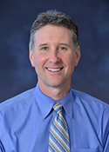**J. Todd Arnedt, Ph.D., DBSM**

Network Director, MICHMED/VAAAHS Postdoctoral Training Programs in Psychology

Program Director, Clinical Psychology Consortium (Michigan Medicine)

Co-Director, Sleep and Circadian Research Laboratory

Director, Behavioral Sleep Medicine Program

[tarnedt@med.umich.edu](mailto:tarnedt@med.umich.edu)

Dr. Arnedt, Ph.D., DBSM is a Professor of Psychiatry and Neurology and Co-Director of the [Sleep and Circadian Research Laboratory](https://medicine.umich.edu/dept/psychiatry/programs/sleep) in the Department of Psychiatry, Michigan Medicine. Dr. Arnedt obtained his Ph.D. in clinical psychology from Queen’s University in Kingston, Ontario, Canada and completed his clinical internship and a two-year postdoctoral fellowship in Behavioral Medicine at the Brown University School of Medicine. Dr. Arnedt is a diplomate of Behavioral Sleep Medicine and directs the Behavioral Sleep Medicine Program, one of only a handful of nationally accredited programs with a primary mission of training the next generation of sleep psychologists. He serves as a primary clinical supervisor in the Behavioral Sleep Medicine clinic. Dr. Arnedt’s primary research interests include sleep and circadian rhythm disturbances in mental health disorders; psychological treatments for sleep disorders; and novel technologies to assess and treat sleep disorders. His research has received support through NIAAA, NIDA, NIMH, and NIMHD. Dr. Arnedt is Associate Editor for the journals Behavioral Sleep Medicine and Sleep Advances and is on the Editorial Board for the journal Sleep.

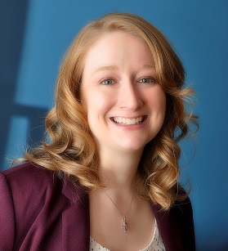

**Erin E. Bonar, Ph.D.**

Substance Abuse Program/Addiction Center

[erinbona@med.umich.edu](mailto:erinbona@med.umich.edu)

Dr. Bonar is an Associate Professor in the University of Michigan Department of Psychiatry. She obtained her Ph.D. in clinical psychology from Bowling Green State University after completing clinical internship at the VAAAHS. Dr. Bonar then completed a two-year post-doctoral fellowship at the University of Michigan Addiction Research Center. Her clinical interests include motivational interviewing and cognitive behavioral treatments for substance use disorders and co-morbid mental health conditions. Dr. Bonar is a member of the Motivational Interviewing Network of Trainers. She is a supervisor for the clinical rotation in the UMHS Addiction Treatment Service. Her research interests include: applications of mobile and digital media technologies to assessment and intervention for substance use and related risk behaviors, brief interventions using motivational interviewing principles, and prevention of substance use problems and related outcomes (e.g., injury, violence, HIV) in adolescents and emerging adults. Her research has received support from NIDA, NIAAA, and CDC Dr. Bonar is also on the Editorial Board for the Journal of Substance Abuse Treatment and the NIH Center for Scientific Review Study Section Community Influences on Behavioral Health.

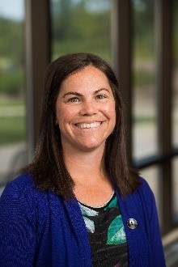**Cynthia Burton, Ph.D.**

Clinical Assistant Professor

Department of Psychiatry

[czburton@umich.edu](mailto:czburton@umich.edu)

Dr. Burton completed her undergraduate degree in psychology at the University of California, San Diego and her Ph.D. in clinical psychology (neuropsychology emphasis) at the SDSU/UCSD Joint Doctoral Program in Clinical Psychology. She completed an APA accredited internship in clinical psychology at the VAAAHS and an APA accredited postdoctoral fellowship in clinical neuropsychology and clinical psychology at the University of Michigan. Dr. Burton’s clinical interests include neuropsychological assessment for those with neurological and psychiatric disorders (particularly schizophrenia and bipolar disorder), and cognitive behavioral therapy for psychosis. She serves as the Clinical and Training Director of PREP (early psychosis) Clinic and supervises pre- and postdoctoral clinical trainees. Broadly, her research interests include recovery-oriented psychosocial interventions for people with schizophrenia, and particularly cognitive remediation to improve cognition and everyday functioning. Historically her research has focused on skills training, with more recent expansion to include non-invasive brain stimulation and computerized cognitive training.

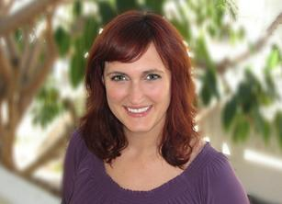**Chelsea Cawood, Ph.D.**

Mental Health Clinic Supervisor

[Chelsea.Cawood@va.gov](mailto:Chelsea.Cawood@va.gov)

Dr. Cawood is a Clinical Psychologist in the outpatient Mental Health Clinic. Dr. Cawood specializes in dialectical behavior therapy for borderline personality disorder, and evidence-based treatments for mood and anxiety disorders. Her research interests include novel adaptations of DBT, non-suicidal self-injury, personality disorders, and effectiveness/ program evaluation of evidence-based treatments in clinical settings. Dr. Cawood earned her Ph.D. from Eastern Michigan University. Dr. Cawood has presented on Acceptance and Commitment Therapy, Cognitive Behavioral Therapy, and Dialectical Behavior Therapy.

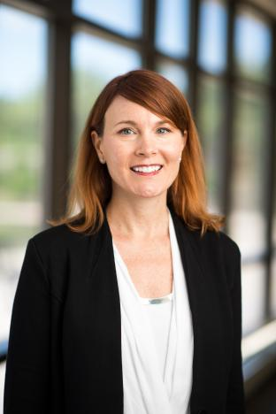**Deirdre A. Conroy, Ph.D., D, ABSM, CBSM, ABPP**

Clinical Director, Behavioral Sleep Medicine Program

[daconroy@umich.edu](mailto:daconroy@umich.edu)

Dr. Conroy is a Clinical Professor in the University of Michigan Department of Psychiatry. She is board certified in Sleep Disorders Medicine by the American Board of Sleep Medicine, in Behavioral Sleep Medicine by the American Academy of Sleep Medicine, and in cognitive behavioral therapy by the American Board of Professional Psychology. Dr. Conroy obtained her Ph.D. in psychology from The City University of New York, New York, NY. She completed her two-year postdoctoral fellowship at the University of Michigan Addiction Treatment Center. Her primary research interests include the relationship between sleep and psychiatric disorders, such as depression and substance use disorders. Her research has received support through Michigan Institute for Clinical and Health Research as well as the Flinn and Berman Foundations. Dr. Conroy serves as one of the clinical supervisors in the Behavioral Sleep Medicine clinical rotation.

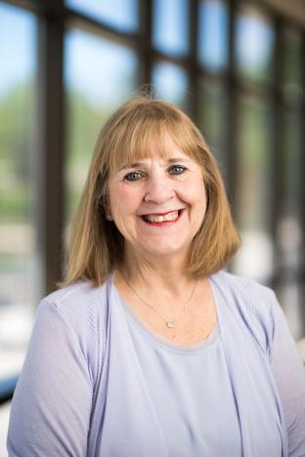**Cathy Donnell, Ph.D.**

Primary Care Mental Health

[cathy.donnell@va.gov](mailto:cathy.donnell@va.gov)

Dr. Donnell is an attending Staff Psychologist for the Primary Care Mental Health Clinic. She holds a Clinical Assistant Professorship at the UM Psychiatry Department and an Adjunct Faculty position with Eastern Michigan University. Dr. Donnell is also associated with private practice work entailing bariatric surgery evaluations and psychotherapy for adults with affective disorders and women with reproductive health issues. She completed her Ph.D. at George Washington University and Postdoctoral Fellowship at the University of Michigan’s Physical Medicine and Rehabilitation Program. Dr. Donnell’s clinical interests include the application and efficacy of Acceptance and Commitment Therapy (ACT) with different clinical populations, application of evidence-based psychotherapies to primary care populations, problem solving therapy/training, and health psychology. Her research foci include Primary Care Mental Health interventions and use of evidence-based therapies, coping with chronic illness, palliative care and family grief responses among Veterans, application of ACT, health psychology and women’s mental and physical health (specifically related to Ob/Gyn), and examination of psychological constructs in the prediction of pain and function among chronic pain populations (e.g., pelvic pain, fibromyalgia, back pain).

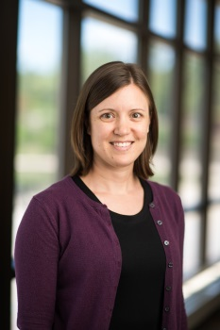**Elizabeth Duval, Ph.D.**

Assistant Professor

[eduval@med.umich.edu](mailto:eduval@med.umich.edu)

Dr. Duval is an Assistant Professor in the Department of Psychiatry at the University of Michigan.  She obtained her Ph.D. in Clinical Psychology at the University of Missouri- Kansas City, completed her clinical internship at the VA Ann Arbor Healthcare System, and conducted postdoctoral work in the University of Michigan - VA Ann Arbor Training Network. Dr. Duval’s primary research interests include identifying neural mechanisms underlying cognitive and emotional processes in anxiety and stress disorders, in an effort to develop more targeted, easily disseminated, and cost-effective treatments. She has been involved in multiple projects using fMRI and physiological measures to investigate differences in brain function associated with emotion regulation, threat reactivity, attentional control, and memory in healthy adults, social anxiety, and PTSD. She has active funding from the National Institute of Mental Health (NIMH) and the Michigan Institute for Clinical and Health Research (MICHR). Dr. Duval is a member of the Society for Psychophysiological Research, the Anxiety and Depression Association of America, and the American College of Neuropsychopharmacology. She co-facilitates the CBT for Anxiety Mentorship for psychiatry trainees, supervises trainees delivering CBT in the outpatient anxiety clinic, and provides individual CBT for adults with anxiety and related disorders.

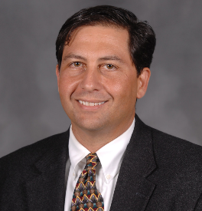**David M. Fresco, Ph.D.**

Co-Director, Michigan Mindfulness

[fresco@med.umich.edu](mailto:fresco@med.umich.edu)

Dr. Fresco is a Professor of Psychiatry, Research Professor at the Institute for Social Research Co-Director of [Michigan Mindfulness](https://michigan-mindfulness.medicine.umich.edu/) in the Department of Psychiatry, Michigan Medicine, and member of the [Data Science for Dynamic Intervention Decision-making Laboratory.](https://d3lab.isr.umich.edu/) Dr. Fresco obtained his Ph.D. in clinical psychology from the University of North Carolina at Chapel Hill, completed his clinical internship at Temple University Medical School, and postdoctoral fellowship at the Adult Anxiety Clinic of Temple University under the direction of Richard G. Heimberg, Ph.D.  Dr. Fresco is a member of the Anxiety Clinic under the direction of James Abelson, MD, Ph.D.  Dr. Fresco’s program of research adopts an affective neuroscience perspective to conduct basic, translational, and treatment studies of anxiety and mood disorders, particularly distress disorders incorporating methodologies including functional neuroimaging (fMRI & EEG), peripheral psychophysiology, and serum markers (e.g., inflammation, neurodegeneration). Another facet of Dr. Fresco’s research has focused on the development of treatments informed by affective and contemplative neuroscience findings that incorporate mindfulness meditation and other practices derived from Buddhist mental training exercises.  Dr. Fresco is one of the originators of [emotion regulation therapy](https://www.emotionregulationtherapy.com/), an evidence-based cognitive behavior therapy informed by affective neuroscience and mindfulness practices with efficacy demonstrated in five published trials and two NIH funded trials presently underway.  Dr. Fresco is PI or Co-I on seven currently funded NIH projects examining neurobehavioral mechanisms and efficacy of mindfulness-enriched treatments for chronic illnesses, and the role of emotion regulation strategies in everyday life to reduce distress.

**Tyler Grove, Ph.D.**

Assistant Professor

tylerg@med.umich.edu

Dr. Grove is a Clinical Assistant Professor in the University of Michigan Department of Psychiatry. He obtained his Ph.D. at the University of Michigan. He completed his clinical internship at the Ann Arbor VA and postdoctoral training at the University of Michigan. Most of his time is spent working in the Anxiety Disorders Clinic, Program for Risk Evaluation and Prevention (PREP) Clinic for Early Psychosis, and Behavioral Sleep Medicine Clinic. Specifically, he works with people who experience OCD, psychosis, and/or sleep disturbances and helps them use CBT interventions such as exposure and response prevention (ERP) for OCD, CBT for psychosis, and CBT for insomnia, respectively. His primary research interests include socioemotional and cognitive predictors of social functioning in severe mental illnesses. He has supervised social work fellows, psychology practicum students, and he is excited to start working with post-docs to help them meet their clinical training goals.

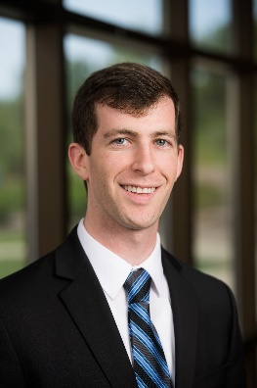

**Adam Horwitz, Ph.D.**

Assistant Professor

[ahor@med.umich.edu](mailto:ahor@med.umich.edu)

Dr. Horwitz is an Assistant Professor in the Department of Psychiatry at the University of Michigan. He received his Ph.D. in Clinical Psychology from the University of Michigan in Ann Arbor, completed his clinical internship at the Edward Hines Jr VA Hospital, and a postdoctoral fellowship at the Road Home Program for Veterans and their Families at Rush University Medical Center in Chicago, IL. Dr. Horwitz’s research interests include risk and protective factors for suicide, coping styles in response to stress, and adaptive mobile health interventions. Clinically, Dr. Horwitz specializes in trauma-focused treatments including Cognitive Processing Therapy and Prolonged Exposure for PTSD. He also provides supervision and individual CBT therapy for anxiety and depression in the Anxiety Disorders Clinic.

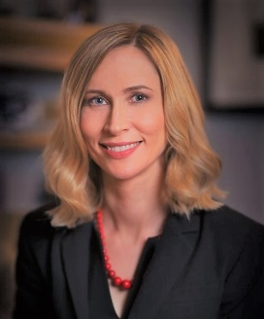**Elizabeth Imbesi, PhD, ABPP**

Integrated Care Chief

[elizabeth.imbesi@va.gov](mailto:elizabeth.imbesi@va.gov)

Dr. Imbesi is the Integrated Care Chief at VAAAHS, overseeing Primary Care Mental Health Integration (PCMHI) and Health Psychology services. She earned her PhD in Counseling Psychology from the University at Buffalo with an emphasis in health psychology. She completed her internship at the VA Western New York Healthcare System and received further specialized training in Health/Primary Care Psychology during her fellowship at Michigan State University College of Human Medicine. Dr. Imbesi’s clinical work is a blend of cognitive-behavioral and interpersonal approaches to promote healthy change and growth. Her clinical and research interests include integrated health care, health psychology, intersectionality, and ethics. She has presented on these topics at local, national, and international conferences. She is board certified in clinical health psychology.

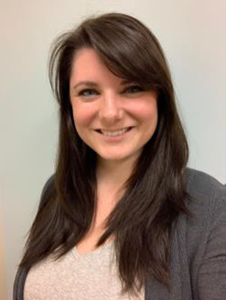

**Jesica Kalmbach, Ph.D.**

Chief of the Substance Use Disorder Clinic

Clinical Assistant Professor University of Michigan Department of Psychiatry

[Jesica.Kalmbach@va.gov](mailto:Jesica.Kalmbach@va.gov)

Dr. Kalmbach is the chief of the Substance Use Disorders Clinic (SUD-C) at the VA Ann Arbor and is a Clinical Assistant Professor at University of Michigan Department of Psychiatry. She earned her Ph.D. in Clinical Psychology from Kent State University. She subsequently completed her postdoctoral fellowship specializing in substance use disorders through the University of Michigan Health System/VA Ann Arbor Health System (UMHS/VAAAHS) Training Consortium. Dr. Kalmbach’s research interests include psychometrics and assessment, specifically validating assessment measures to inform individualized treatment plans and assess evidence-based protocol outcomes. Currently, Dr. Kalmbach is investigating the validity of the WHODAS 2.0 in Veterans seeking SUD treatment and the demographic characteristics of Veterans engaged in Buprenorphine treatment. Clinically, Dr. Kalmbach is interested in assisting Veterans develop concrete goals for treatment through Motivational Interviewing, improving functioning, and reducing substance use through the use of Evidence Based Protocols, especially through group form.

**Naomi Kane, Ph.D.**

Primary Care Mental Health

Health Psychology

Dr. Kane is a Clinical Health Psychologist at the VA Ann Arbor Healthcare System, working in Primary Care Mental Health Integration (PCMHi) and the Women’s Health Clinic. She received her PhD in Clinical Psychology with Health Emphasis from Yeshiva University in the Bronx, NY, completing her predoctoral internship in the health psychology track at the VA Ann Arbor and a 2-year clinical research postdoctoral fellowship at the New Jersey VA WRIISC (War Related Illness and Injury Study Center) in oncology, behavioral medicine, and post-deployment health. Clinically, her interests include cognitive behavioral and problem-solving therapies, reproductive mental health, and a Whole Health integrative approach to recovery from trauma. Dr. Kane’s research broadly focuses on improving illness specific distress and self-management behavior for Veterans with chronic illness through evidence-based practice and collaborative care.

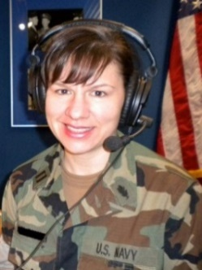

**Rebecca Lusk, Psy.D., ABPP**

Mental Health Clinic and DBT

Chief, Mental Health Clinic (MHC)

[rebecca.lusk@va.gov](mailto:rebecca.lusk@va.gov)

Dr. Lusk is the Chief of the Canton CBOC VA Mental Health Clinic. She is an Assistant Professor in the Department of Psychiatry, Michigan Medicine. Dr. Lusk completed her Psy.D. at the University of Indianapolis and her postdoctoral fellowship with the Consortium for Advanced Psychology Training, Michigan State University, College of Human Medicine. She is an ABPP Diplomate, and board certified in Dialectical Behavior Therapy through the DBT-Linehan Board of Certification. Her clinical interests include cognitive behavioral applications and treatment outcomes, health and behavior change, borderline personality disorder, and dissemination of empirically supported treatments. She is involved in research activities concentrating on pre-treatment intervention in preparation for psychotherapy and program evaluation outcomes.

**Saudia Major, Ph.D.**

Chief, Health Psychology

[Saudia.Major@va.gov](mailto:Saudia.Major@va.gov)

Saudia Major, Ph.D., Clinical Psychologist, is the Chief of Health Psychology at the LTC Charles S. Kettles VAMC. Dr. Major spent the previous 15 years in this VA’s Home Based Primary Care (HBPC) program, providing behavioral health care to chronically ill Veterans in their homes. She is a Clinical Instructor with the University of Michigan, School of Medicine, Dept. of Psychiatry, and a member of the VA psychology training program. Dr. Major earned her bachelor’s degree (Magna Cum Laude) and doctorate degree in Clinical-Community Psychology from the University of South Carolina and completed her internship and residency at Florida State Hospital, a forensic psychiatric hospital in Chattahoochee, FL. Clinical interests include designing, implementing, and evaluating evidence-based interventions for older adults; suicide prevention; dementia care and caregiver stress. Dr. Major helped innovate the Ann Arbor VA’s caregiver support program by serving in a collateral role as the hospital’s first Caregiver Support Coordinator. Dr. Major has been involved in research examining the reliability and factor structure of the Saint Louis University Mental Status Exam and exploring the benefits of exercise on disease management, specifically mental illness, and Multiple Sclerosis. Prior areas of research have included attachment theory, relationship satisfaction, and cardiovascular reactivity.

**Clayton “Beau” Nelson, Ph.D.**

Psychosocial Rehabilitation & Recovery and Applied Clinical Research Chief, Community Outreach; Local Recovery Coordinator

Postdoctoral Fellowship VA Adult Track Lead

[Clayton.Nelson2@va.gov](mailto:Clayton.Nelson2@va.gov)

Dr. Nelson is a Clinical Psychologist, Chief of Community Outreach, and the Local Recovery Coordinator for the VA Ann Arbor Healthcare System and holds an Assistant Professorship with the Department of Psychiatry, Michigan Medicine. He also serves as the VA lead for the UM/VA Adult Track of the Postdoctoral Consortium. Dr. Nelson completed his doctoral degree at the University of Missouri-Kansas City and attended an Interprofessional Postdoctoral Fellowship in Psychosocial Rehabilitation and Recovery at the San Diego VA. His clinical interests include psychosocial rehabilitation, cognitive-behavioral therapy, motivational interviewing, and mental health recovery for individuals diagnosed with serious mental illness. His research concentrates on predictors of treatment engagement and adherence, models of mental health care, and social determinants of mental illness.

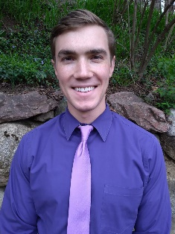**Tyler Pendleton, Ph.D.**

Pain Psychologist

Dr. Pendleton is a Clinical Psychologist in the Pain Clinic at the Canton Community Care Mental Health Based Outpatient Clinic (CBOC). He earned his Ph.D. from the University of Missouri-St. Louis and completed his postdoctoral fellowship at the Michigan Medicine/VA Ann Arbor Healthcare System Consortium. His clinical interests are focused within Cognitive Behavioral Therapy for Chronic Pain. He is broadly interested in program evaluation focused on patient-provider communication and access to healthcare.

**Katherine Porter, Ph.D.**

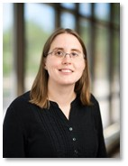PTSD and Applied Research

Chief, PTSD Clinical Team

[Katherine.Porter2@va.gov](mailto:Katheirne.Porter2@va.gov)

Dr. Porter is the Chief of the PTSD Clinic at the Ann Arbor VA and Clinical Associate Professor with the University of Michigan Medical School. She earned her doctoral degree at Eastern Michigan University. Dr. Porter’s clinical and research foci include treatment outcomes with Veterans experiencing PTSD; improving access to care and retention in empirically supported PTSD interventions; the intersections of trauma and somatic/pain complaints; and trauma and aging. She is actively involved in several research activities with the PTSD Research Team. In addition, Dr. Porter has an interest in applied biomedical ethics and is currently co-chair for ethics consultation within VAAAHS.

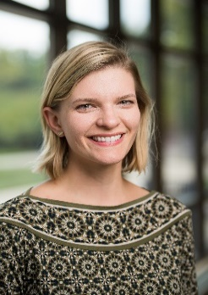**Greta Raglan, Ph.D.**

Clinical Assistant Professor

[gbielacz@med.umich.edu](mailto:gbielacz@med.umich.edu)

Dr. Raglan, Ph.D., is a Clinical Assistant Professor in the University of Michigan Department of Psychiatry. Dr. Raglan obtained her Ph.D. in Clinical Psychology from American University in Washington, D.C. and completed her clinical internship at the Catholic University of America Counseling Center. Following her internship, Dr. Raglan completed a two-year postdoctoral fellowship at the University of Michigan Department of Psychiatry. Dr. Raglan’s primary clinical and research interests are in sleep and perinatal mental health. She is a clinical supervisor in the Women and Infants Mental Health Clinic as well as within the Behavioral Sleep Medicine Clinic.

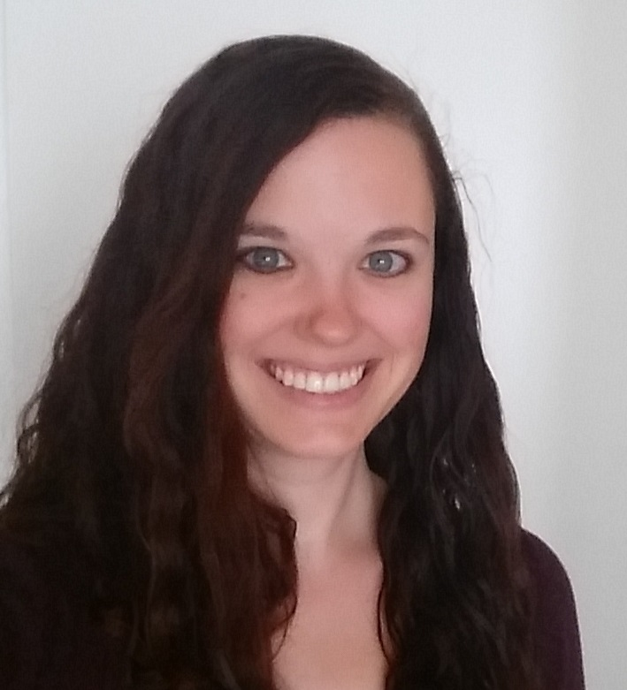**Jessica Schubert, Ph.D.**

Mental Health Clinic, Telemental Health, and Sleep Clinic

[Jessica.Schubert@va.gov](mailto:Jessica.Schubert@va.gov)

Dr. Schubert is a Staff Psychologist in the outpatient Mental Health Clinic and the Telemental Health Clinic. She additionally has clinical time allocated to the Sleep Clinic, where she provides behavioral sleep medicine assessment and intervention services for Veterans presenting with insomnia, sleep apnea, and nightmares. Dr. Schubert holds a Clinical Assistant Professor appointment at the University of Michigan Medical School, Department of Psychiatry. She earned her Ph.D. from Binghamton University (SUNY) with specialization in EBPs for anxiety disorders, and she completed her pre-doctoral internship at the Durham Veterans Affairs Medical Center. Dr. Schubert completed postdoctoral fellowship at the University of Michigan Department of Psychiatry which emphasized both research and clinical practice with a dual concentration in Behavioral Sleep Medicine and Anxiety Disorders. Clinical and research interests include improving the quality, efficiency, and dissemination of EBPs for anxiety disorders and understanding the impact of sleep disturbance on mental health as it relates to treatment outcomes.

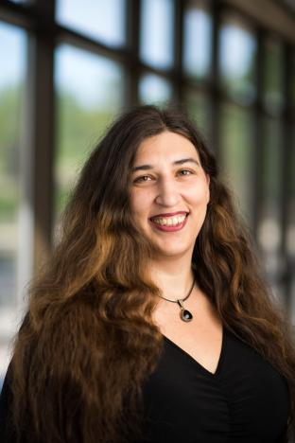**Minden B. Sexton, Ph.D.**

Women Veterans’ Mental Health Coordinator

VA Ann Arbor Director of Clinical Psychology Training

Women Veterans’ Mental Health and Applied Research

[Minden.Sexton@va.gov](mailto:Minden.Sexton@va.gov)

Dr. Sexton is the Women Veterans’ Mental Health Coordinator, a Staff Psychologist in the PTSD Clinic, and a Clinical Associate Professor with the University of Michigan Medical School. She obtained her Ph.D. in at Eastern Michigan University and postdoctoral training at the UM Medical School. Her primary clinical work entails evaluation and therapy services related to trauma (PTSD and other clinical presentations associated with interpersonal violence and military/non-military sexual trauma). She supervises the Women Veterans’ Mental Health and Applied Research rotations, facilitates trainee engagement in women’s mental health administration, and provides training in the assessment and treatment of disordered sleep. She is the PIs for studies on a study examining Veterans’ engagement, retention, and clinical outcomes following military sexual trauma (MST) and our Mental Health Services’ study on mental and medical outcomes and service use utilizing psychosocial, clinical, laboratory, and other clinical indicators. Her primary research interests are PTSD; MST and other interpersonal traumas; diversity, equity, and inclusion in mental health care; peripartum mental health; psychometrics; sleep; and predictors of PTSD treatment and health services engagement, retention, and outcomes.

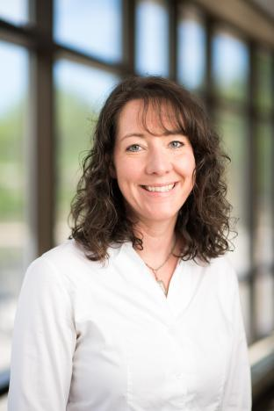**Erin Smith, Ph.D.**

PTSD Clinical Team

PTSD and Applied Research

[Erin.Smith3@va.gov](mailto:Erin.Smith3@va.gov)

Dr. Smith is a psychologist in PTSD Clinical Team. She is an Assistant Clinical Professor with the Department of Psychiatry, University of Michigan Medical School. She attained her doctoral degree from Fuller Seminary and completed postdoctoral training in PTSD at the Ann Arbor VA. Administratively, Dr. Smith is a VISN 10 PTSD mentor and provides support and guidance to clinic leaders in PTSD programs throughout the VISN. In this role she is involved in policy implementation and program improvement in accordance with national directives for PTSD care. Dr. Smith is a certified trainer and consultant in Prolonged Exposure (PE) Therapy and provides supervision of Interns utilizing PE or Cognitive Processing Therapy (CPT). Her clinical and research interests entail evidence-based interventions for PTSD, development of clinical interventions for PTSD, provision of evidence-based PTSD interventions in group formats, partner/support involvement in implementation of PE, perceived perpetration, and spirituality and trauma.

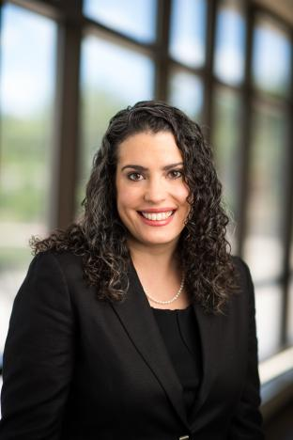**Leslie Swanson, Ph.D., CBSM**

Sleep and Circadian Research Laboratory

[lmswan@med.umich.edu](mailto:lmswan@med.umich.edu)

Dr. Swanson, Ph.D., DBSM, is a Clinical Associate Professor in the University of Michigan Department of Psychiatry. Dr. Swanson obtained her Ph.D. in clinical psychology from the University of Alabama. She completed her clinical internship at the Veterans Affairs Ann Arbor Healthcare System, followed by a two-year postdoctoral fellowship at the University of Michigan Department of Psychiatry. Dr. Swanson’s research and clinical work are focused on sleep and circadian rhythms in mental health, with a specific emphasis on women’s health. Dr. Swanson provides supervision in the Women and Infants Mental Health Clinic and within the Behavioral Sleep Medicine Clinic. Her research has received support through NHLBI and NIMH.

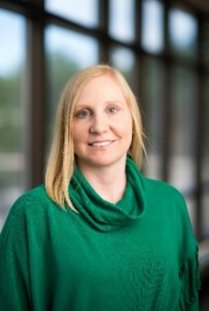**Lisa Valentine, Ph.D.**

Mental Health Clinic/Telemental Health

[lisa.valentine@va.gov](mailto:lisa.valentine@va.gov)

Dr. Valentine is a BHIP team lead in the Mental Health Clinic, a Clinical Assistant Professor in the Department of Psychiatry at University of Michigan and has served as the facility Telemental Health Champion. She completed her Ph.D. in Clinical Health Psychology and Behavioral Medicine at the University of North Texas. She served on active duty in the United States Air Force during her internship and post-doctoral training. During her time in the military, she worked as a staff provider in the Mental Health Clinic, an element leader in the substance abuse prevention and treatment program, and as suicide prevention program manager. She serves as primary supervisor for the telemental health major and minor rotations. Clinical interests include providing evidence-based psychotherapies to rural and remote veterans and health behavior change. Her past research has focused on posttraumatic growth and meaning making following stressful events. Current research interests include efficacy and effectiveness of telemental health services, as well as quality improvement projects for the telemental health team.

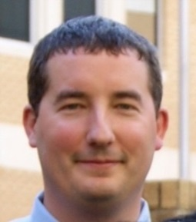**Joseph VanderVeen, Ph.D.**

Associate Chief of Clinical Operations for the Mental Health Service

[Joseph.Vanderveen3@va.gov](mailto:Joseph.Vanderveen3@va.gov)

Dr. VanderVeen is the Chief of the Mental Health Service and holds a Clinical Assistant Professor position with the Department of Psychiatry, University of Michigan Medical School. He earned his doctoral degree in Clinical Psychology at Texas Tech University and completed his internship at the University of Mississippi/G.V. (Sonny) Montgomery VAMC consortium. Following this, Dr. VanderVeen completed a postdoctoral fellowship with an emphasis on substance use and co-occurring PTSD at the G.V. (Sonny) Montgomery VAMC. Throughout his training and career, Dr. VanderVeen’s clinical work and research has focused on systematically exploring how individual differences and behavioral choices can contribute to the maintenance of unhealthy decision-making. More specifically, his focus has been on understanding predictors of unhealthy behaviors, such as drug and alcohol use, and how relapse can be better anticipated and treated among a variety of populations. Dr. VanderVeen has also published several articles on training and competency measures within clinical psychology doctoral programs as well as the internship match. Dr. VanderVeen serves as primary supervisor for the substance use disorder rotations.

**Tessa Vuper, Ph.D.**

Staff Psychologist, PTSD Clinical Team, VA Ann Arbor Healthcare System

Clinical Assistant Professor, Michigan Medicine Dept. of Psychiatry

[Tessa.Vuper@va.gov](mailto:Tessa.Vuper@va.gov)

Dr. Vuper is a Staff Psychologist in the PTSD Clinic. She obtained her Ph.D. in Clinical Psychology from the University of Missouri-St. Louis and completed her postdoctoral fellowship through the Ann Arbor VA/University of Michigan Training Consortium. Her clinical interests are in evidence-based treatments for PTSD. Broadly, her research interests are in understanding mechanisms of therapeutic change and enhancing clinical outcomes in trauma and stressor-related disorders. She is particularly interested in using neuroimaging methods to investigate the effect of clinical interventions on brain functioning in individuals with PTSD. Dr. Vuper is presently collaborating with researchers at Yale University investigating resting-state functional connectivity and clinical correlates across multiple timepoints in individuals with trauma exposure, Borderline Personality Disorder, and suicidal behavior.

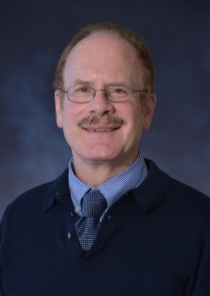**L. Ricks Warren, Ph.D., ABPP**

Clinical Professor

Department of Psychiatry

[ricksw@med.umich.edu](mailto:ricksw@med.umich.edu)

Dr. Warren, Ph.D., ABPP, is a Clinical Professor in Psychiatry in the University of Michigan Department of Psychiatry. Dr. Warren obtained his Ph.D. in Psychology at the University of Oregon in Eugene, Oregon, and completed his clinical internship at the University Counseling Center at UO in Eugene and the Veteran’s Administration Medical Center in Portland, Oregon. Dr. Warren is certified by the American Board of Professional Psychologists. Dr. Warren’s primary research interests include assessment and treatment of worry and self-criticism; self-compassion interventions; and the effectiveness of evidence-based CBT treatment of anxiety disorders. He is on the editorial board of the Journal of Rational Emotive and Cognitive Behavior Therapy and serves as a reviewer for conference submissions to the Anxiety and Depression Association of America (ADAA). He is a Fellow of the Association for Behavioral and Cognitive Therapies (ABCT). Dr. Warren conducts the CBT for Depression Mentorship for psychiatry fellows, clinical social workers, and nurse practitioners and provides both individual and group CBT for adults with anxiety and depression.

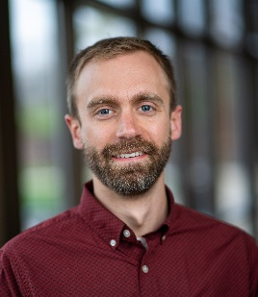**Alex Weigard, Ph.D.**

Assistant Professor

Department of Psychiatry

[asweigar@med.umich.edu](mailto:asweigar@med.umich.edu)

Dr. Weigard is an Assistant Professor in Michigan Medicine’s Department of Psychiatry. Dr. Weigard obtained his Ph.D. in clinical psychology, with a research specialty in cognitive and affective neuroscience, at Penn State University and completed his clinical internship at the Ann Arbor VA Healthcare System. He then completed an NIAAA-funded T32 postdoctoral fellowship in the Addiction Center at the University of Michigan Department of Psychiatry. Dr. Weigard conducts research focused on using computational and network modeling methods to better characterize cognitive and neural risk factors for the development of attention problems and substance use disorders. His research is currently funded by a NIDA K23 award. Dr. Weigard’s clinical interests include empirically supported diagnosis and treatment of substance use disorders, ADHD and related psychopathology across the life span using behavioral and cognitive behavioral frameworks. He supervises trainees in the University of Michigan Addiction Treatment Services (UMATS) clinic.

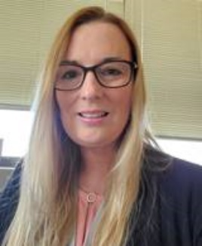**Jamie J. Winters, Ph.D.**

Associate Chief of Mental Health for Quality & Policy and Chief Psychologist

SUD, Couples & Family Therapy, Administrative Leadership & Applied Clinical Research

[jamiewin@umich.edu](mailto:jamiewin@umich.edu)

Dr. Winters serves as the Associate Chief of Mental Health for Quality & Policy and Chief Psychologist of the Mental Health Service and a Clinical Associate Professor at the University of Michigan Department of Psychiatry. She earned her doctoral degree at the University of Maryland, Baltimore County and completed a postdoctoral fellowship at the Research Institute on Addictions. Dr. Winters supervises a number of clinical experiences including Behavioral couples and family therapy, intimate partner violence intervention, and interventions for Substance use and disorders co-occurring with SUD. She serves as a national trainer for the Strength at Home program, and provides workshops in BCT for SUD. These training programs have resulted in certification and equivalency status in VA for those who participate. Dr. Winters focuses on research elucidating factors associated with substance use disorders and treatment outcome, substance use and violence, behavioral couples therapy, and intimate partner violence.  Current projects include an RCT evaluating a brief peer-based intervention for alcohol problems identified in the ED and a new RCT evaluating a Brief MI based pretreatment for alcohol problems prior to participation in Strength at Home. She is interested in collaborating on the ongoing evaluation of the SUD program and factors influencing treatment outcome as well. Dr. Winters also offers a variety on learning opportunities related to administrative leadership covering the spectrum of leadership issues that commonly arise.

# ANN ARBOR LIFE AND COMMUNITY

Michigan Medicine and VA Ann Arbor Healthcare System are located within the mid-sized city of Ann Arbor. The 2019 Census recorded the Ann Arbor population to be 119,980, making it the sixth largest city in Michigan. Ann Arbor is renowned for its cultural offerings, cuisine, and is home to an avid base of sport enthusiasts. Ann Arbor has you covered year-round, whether you enjoy arts, sports or recreational

activities, shopping, festivals, casual or fine dining, family-friendly activities, or nightlife. Ann Arbor is also home to award winning public schools and higher learning universities and colleges. To learn more about life at Michigan Medicine and living in Ann Arbor, check out the [Go Blue Guide](https://goblueguide.medicine.umich.edu/) and [Destination Ann Arbor](https://www.annarbor.org/?gclid=CjwKCAjwieuGBhAsEiwA1Ly_na3aG5elzw2OguMCWOD2mcSGElM-a1VFTKp7xJoOXR73ibcLHuevghoCpT0QAvD_BwE).



Photo: AACVB

Photo: Chicago Tribune

Photo: Angela J. Cesere | The Ann Arbor News

Awards and Accolades: (<https://www.visitannarbor.org/about>)

#1 [Location for Family Vacation](https://vacationidea.com/weekend-getaways/best-family-vacations.html), *Vacation Idea, 2019*

#1 [2018-2019 Best in College Sports](https://www.cbssports.com/college-football/news/best-in-college-sports-michigan-edges-kentucky-to-bring-the-2018-19-award-to-ann-arbor/), *CBS Sports, 2019*

[Living Lab for City Mobility](https://medium.com/cityoftomorrow/how-ann-arbor-michigan-became-a-living-lab-for-city-mobility-daf93672b5d0), *Medium, 2019*

#6 [One of the Top Startup Cities in the Midwest](https://www.americaninno.com/chicago/inno-insights-chicago/these-are-the-top-startup-cities-in-the-midwest-according-to-a-new-report/), *Chicago Inno, 2019*

#2 [One of the Best Cities to Live in America](https://www.niche.com/places-to-live/search/best-cities/), *Niche, 2019*

#3 [Unexpectedly Awesome Coffee Cities](https://livability.com/top-10/food-and-drink/10-unexpectedly-awesome-coffee-cities/mi/ann-arbor), *Livibility, 2019*

[One of the Top 5 Car-Free Small Metros](https://www.citylab.com/life/2019/09/where-live-no-car-america-public-transit-transportation/598606/), *City Lab, 2019*

#47 [Best Places to Live in America](http://money.com/money/collection/2018-best-places-to-live/), *TIME, 2018*

#1 [Eastern Michigan University Recognized as Michigan’s Top LGBTQ- Friendly University](https://www.affordablecollegesonline.org/college-resource-center/lgbtq-college-rankings-2018-2019/),

*AffordableCollegesOnline, 2018*

#1 [Most Educated City in America](https://wallethub.com/edu/e/most-and-least-educated-cities/6656/), *WalletHub, 2018*

#1 [University of Michigan the Top Public University in U.S.](https://www.clickondetroit.com/all-about-ann-arbor/ranking-university-of-michigan-no-1-public-university-in-us?beta=true), *All About Ann Arbor, 2018*

#1 [Top 100 Best Places to Live](https://livability.com/list/top-100-best-places-to-live/2018/10), *Livability.com, 2018*

#2 [Top 10 Best Places to Raise a Family](https://livability.com/top-10/families/10-best-places-to-raise-a-family/2018/mi/ann-arbor), *Livability, 2018*

**Clinical Psychology Application Process**

Applications to the Clinical Psychology Consortium can be completed through the [APPA CAS](https://appicpostdoc.liaisoncas.com/applicant-ux/#/login) system. The deadline for applications is December 1. A complete application consists of the following:

* + Completed APPA CAS application
  + Cover letter
  + Current curriculum vitae
  + Graduate School transcript
* A Letter of Support from your Director of Clinical Training (DCT) attesting to your readiness to graduate on time from your graduate program.
  + Three (3) Letters of Recommendation

For general questions about the program, contact the Program Coordinator Danielle Hayes ([UM-VA-PostdocApply@umich.edu](mailto:UM-VA-PostdocApply@umich.edu) or 734-763-4872). For specific inquiries about opportunities at the MICHMED site, contact J. Todd Arnedt, Ph.D., MICHMED Program Director ([tarnedt@med.umich.edu](mailto:tarnedt@med.umich.edu)); for questions about the VAAAHS site, contact Beau Nelson, Ph.D. VAAAHS Program Director (Clayton.Nelson2@va.gov).

The MICHMED/VAAAHS Consortium offers stipends currently range from $57,224-$60,317 for 1st and 2nd year fellows, respectively. In addition, fellows are eligible for medical benefits, paid vacation days, and travel support for professional development.

Candidate interviews take place typically in January and February. After a review of applications, individuals will be contacted for interview, which will be conducted entirely virtually again this year.

Eligibility requirements for a postdoctoral position at the Michigan Medicine site are described in our [Recruitment and Selection Policy](https://psych.med.umich.edu/downloads/recruitment_and_selection_policy_ptc_approved_tuLF7WKtVOKR_xWSZI6jVg4Re.pdf). Additional eligibility requirements for postdoctoral positions at the VAAAHS site are outlined [here](https://www.psychologytraining.va.gov/eligibility.asp). All the policies governing our Network of psychology postdoctoral training programs can be found [here](https://medicine.umich.edu/dept/psychiatry/education/psychology-postdoctoral-training)

